 

**To Supply Leftover Food to Poor**

**Project Overview:-**

**Food Connect :- This system is built to organize and streamline food donation events, distribution, and logistics by utilizing Salesforce’s CRM features. It aids in monitoring donors, volunteers, venues, and resources, while also automating tasks like event planning, communication, and reporting. This enables smooth coordination for food donation and distribution activities.**

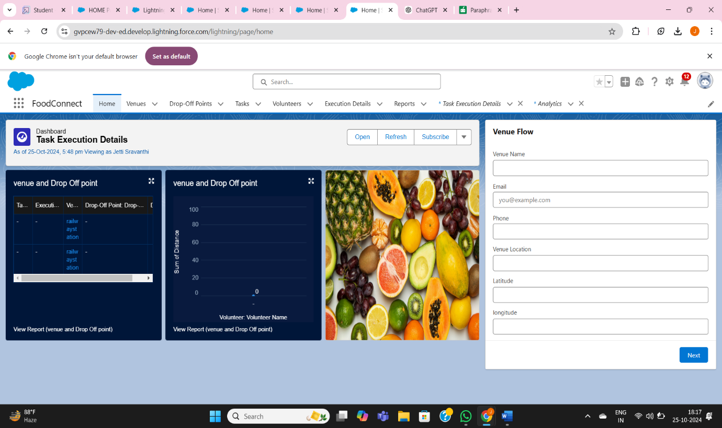

**OBJECTIVES**

**OBJECTS**

**Venue Object:** Tracks and manages event locations designated for food donation and distribution within the Food Connect project.

**Drop-Off Point Object:** Monitors and organizes designated locations specifically for food donation drop-offs in the Food Connect project.

**Task Object:** Manages and oversees activities and responsibilities associated with food donation events in the Food Connect project.

**Volunteer Object:** Tracks and manages individuals who provide assistance during food donation events and related activities within the Food Connect project.

**Execution Details**: Object: Keeps track of detailed operational elements and monitors the progress of food donation events in the Food Connect project.

**TABS**

**Venue Object:** Tracks and manages event locations designated for food donation and distribution within the Food Connect project.

**Drop-Off Point Object:** Monitors and organizes designated locations specifically for food donation drop-offs in the Food Connect project.

**Task Object:** Manages and oversees activities and responsibilities associated with food donation events in the Food Connect project.

**Volunteer Object:** Tracks and manages individuals who provide assistance during food donation events and related activities within the Food Connect project.

**Execution Details**: Object: Keeps track of detailed operational elements and monitors the progress of food donation events in the Food Connect project.

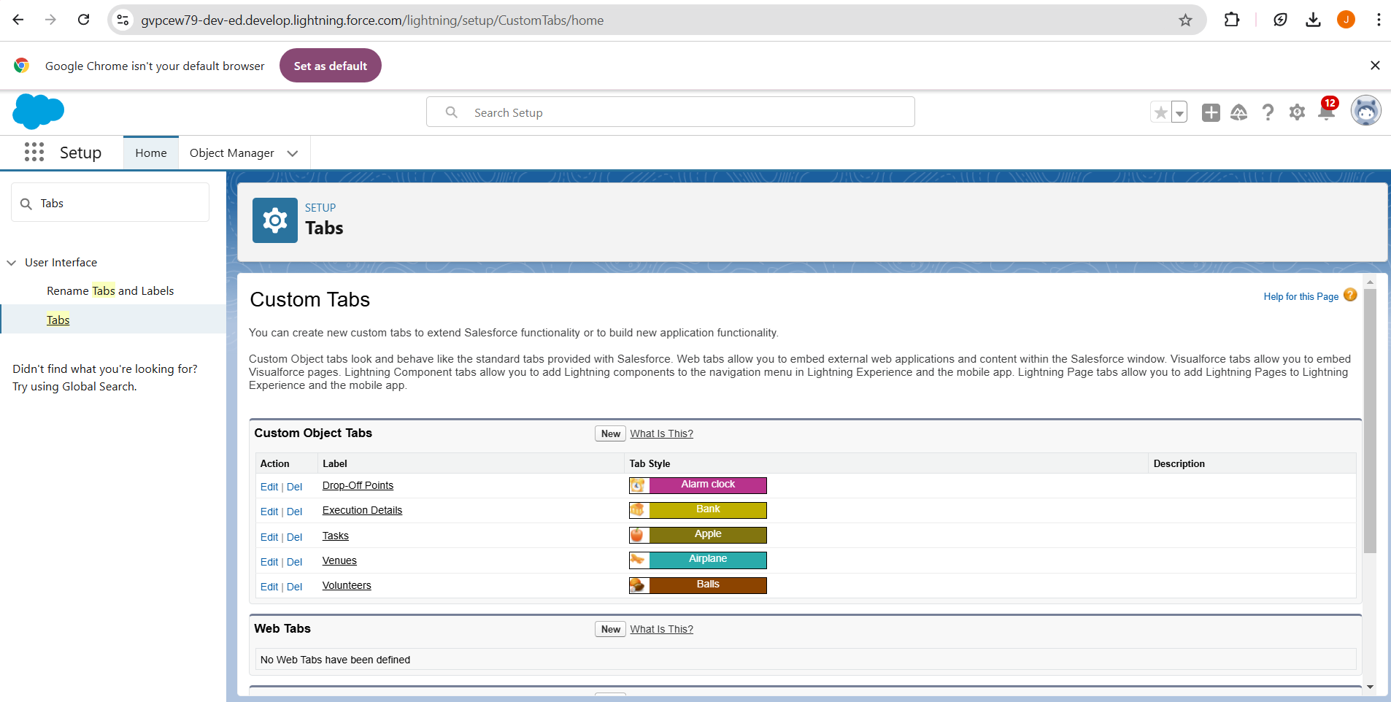

**Lightning App :-**

1. App Name: FoodConnect
2. Developer Name: FoodConnect
3. Image: Optional
4. Primary Color Hex Value: Default
5. Navigation Style: Standard Navigation
6. Utility Items: Default (no custom utility items added)
7. Navigation Items:
   * Home
   * Venue
   * Drop-Off Point
   * Task
   * Volunteer
   * Execution Details
   * Reports
8. User Profile: System Administrator

**Salesforce Key Features and Concepts Utilized**

**Field and Relationships:-**

**Lookup Relationship (Volunteer to Drop-Off Point):** Allows volunteers to be linked to multiple drop-off points flexibly, without enforcing strict dependencies.

**Master-Detail Relationship (Execution Details to Volunteer):** Ensures that execution details are directly tied to a specific volunteer, maintaining data integrity with cascading deletions.

**Master-Detail Relationship (Execution Details to Task):** Establishes a dependency where execution details must be associated with a task, ensuring the context of each task.

**Lookup Relationship (Drop-Off Point to Venue):** Provides flexibility for drop-off points to connect to multiple venues without enforcing rigid dependencies.

**Lookup Relationship (Task to Venue - Sponsored By):** Allows tasks to optionally link to a venue for sponsorship purposes without requiring task presence.

**Lookup Relationship (Task to Drop-Off Point):** Enables tasks to optionally connect with drop-off points, supporting tasks that might not be tied to a specific location.

**Detailed Steps to Solution Design**

**Flow:-**

The flow is designed to automate the process of creating records in the Venue object, ensuring efficient data entry and enhancing user experience. The following components are used in this flow:

**Screen Flow**: Allows user interaction, guiding users to input data in a structured format.

**Components and Their Purpose**

* + **Screen Element (Venue Details)**: This interface collects essential venue information from users.
  + **Text Component (Venue Name)**: Captures the name of the venue for clear identification.
  + **Email Component (Contact Email)**: Collects the primary contact’s email to facilitate venue-related communication.
  + **Phone Component (Contact Phone)**: Gathers a phone number for direct communication if needed.
  + **Text Component (Venue Location)**: Allows users to enter the physical address or location, crucial for logistics.
  + **Number Component (Latitude)**: Captures the latitude for mapping and location services.
  + **Number Component (Longitude)**: Captures the longitude, completing the geographic coordinates for precise location details.
* **Create Record Element (Create Venue Record)**: Saves all provided venue details into the database, ensuring accurate and complete data storage.

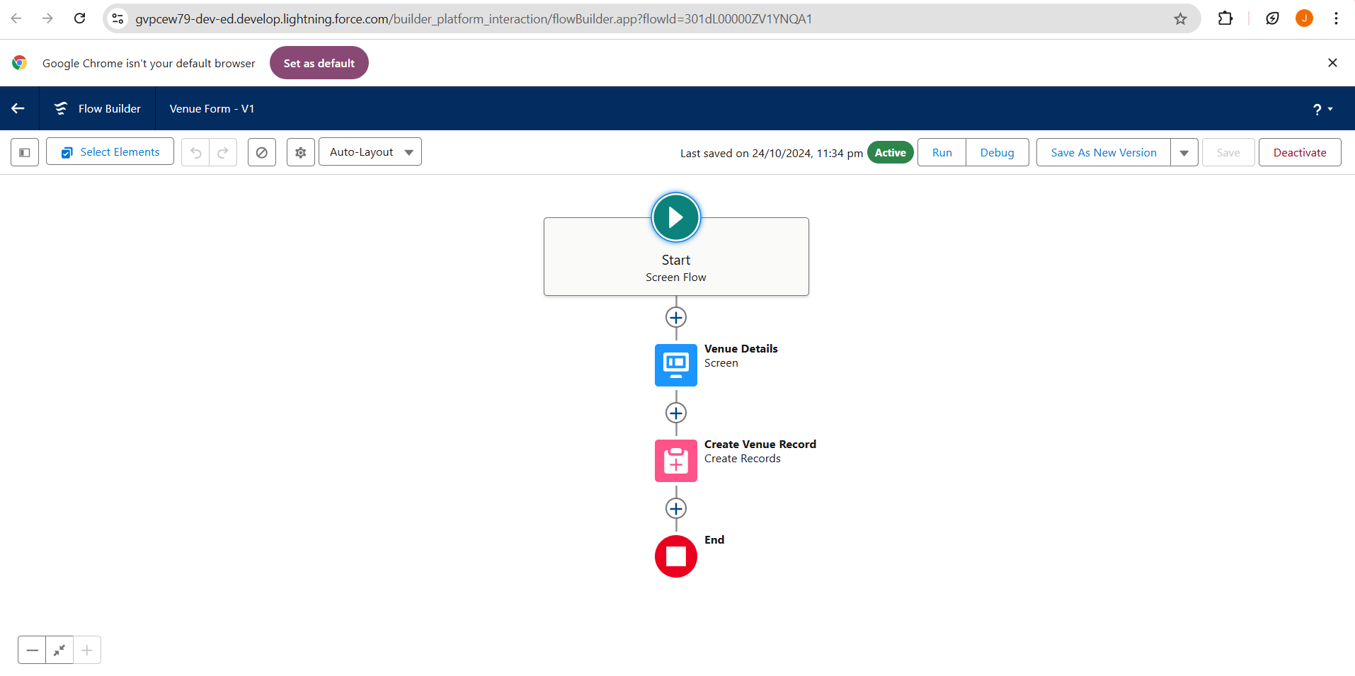

**Testing and Validation**

**Trigger:-**

A Salesforce trigger enables automation and the enforcement of business logic by executing actions when records in the **Drop-Off Point** object are created, updated, or deleted. This functionality helps maintain data integrity and enhances the application's responsiveness by reacting in real time to user interactions with these records.

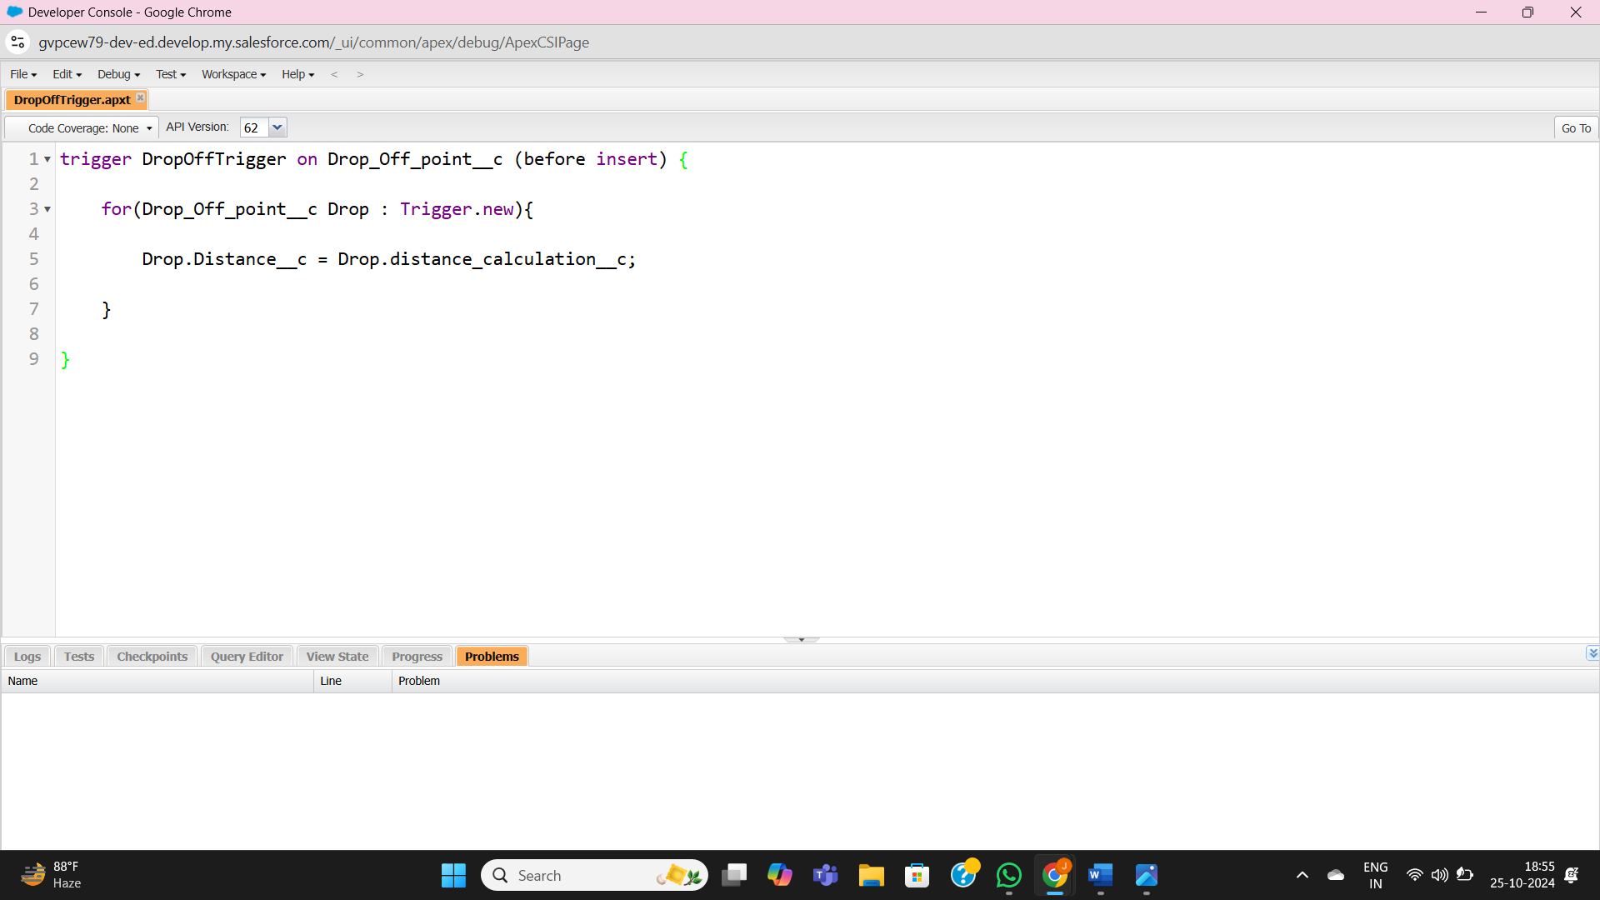

**Key Scenarios Addressed by Salesforce in the Implementation Project**

**Profiles:-**

To create a custom profile for specific user access and permissions**.** NGOs Profile.

Creation of User1

* Purpose: To create a new user in Salesforce with specific details tailored for NGO use.
* User Details:
  + First Name: Iksha Foundation
  + Last Name: Iksha_Foundation
  + Alias: iiksh
  + Email: iiksh@gmail.com
  + Username: ikshafoundation@sb.com (ensure it's unique)
  + Nickname: Auto Populated
  + User License: Salesforce Platform
  + Profile: NGOs Profile
  + Active: Checked

This user will be configured to have access tailored for nonprofit operations.

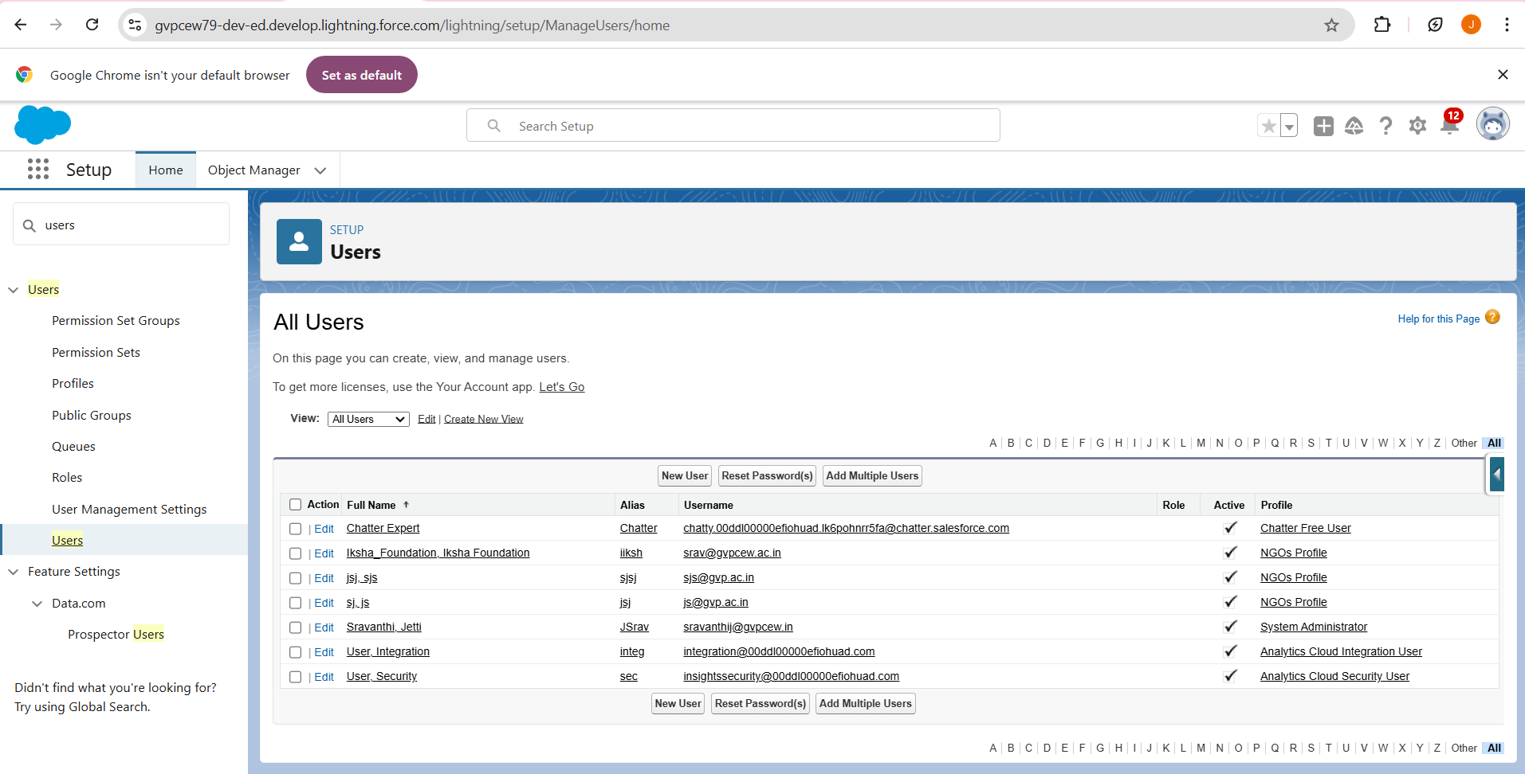

**Report Types**:-

To generate custom reports that provide insights on relationships between Venues, Drop-Off Points, and Volunteers.

* Keywords:
  + Primary Object: Venues
  + Report Type Label: Venue with DropOff with Volunteer
  + Report Type Name: Venue_with_DropOff_with_Volunteer
  + Store in Category: Other Reports
  + Deployment Status: Deployed
  + Related Objects: Drop-Off Points, Volunteers
  + Relationship Option: "A" records may or may not have related "B" records

This report type helps create comprehensive reports combining data from Venues, Drop-Off Points, and Volunteers, enabling effective data analysis for nonprofit activities.

**Reports:-**

Creation of Report on Venue with DropOff with Volunteer

* Purpose: To generate a custom report showing relationships between venues, drop-off points, and volunteers.
* Report Name: venue and Drop Off point
* Report Type: Venue with DropOff with Volunteer
* Group Rows by: Volunteer Name
* Columns: Venue Name, Drop-Off point Name, Distance
* Folder: Custom Reports

This report helps track and analyse volunteer activities across venues and drop-off points, facilitating operational management for nonprofits.

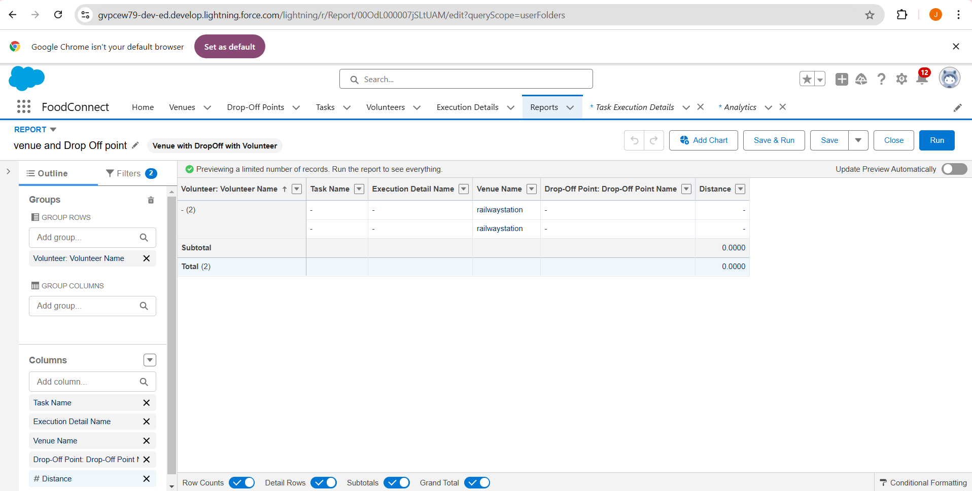

Creation of Report on Volunteers with Execution Details and Tasks

* Purpose: To generate a detailed report showing volunteer tasks, execution details, and performance ratings.
* Report Name: Volunteer Task
* Report Type: Volunteers with Execution Details and Tasks
* Group Rows by: Volunteer ID
* Columns: Volunteer Name, Task Name, Execution Detail Name, Volunteer Owner Name, Task Date, Task Rating
* Folder: Custom Reports

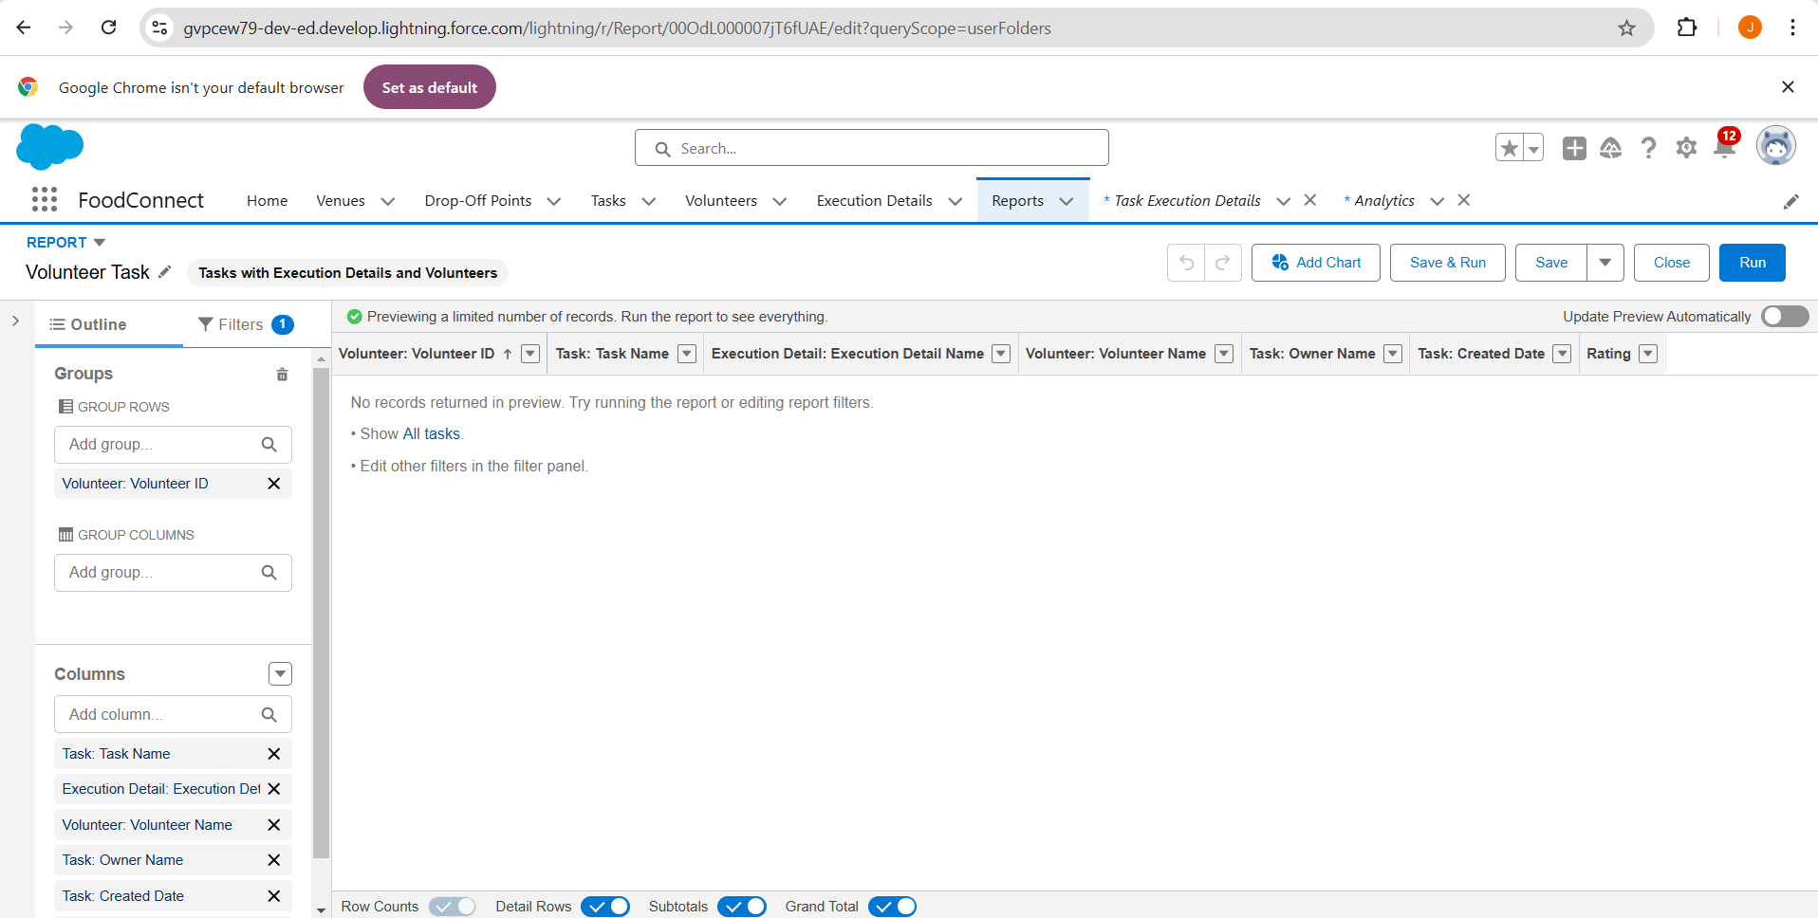

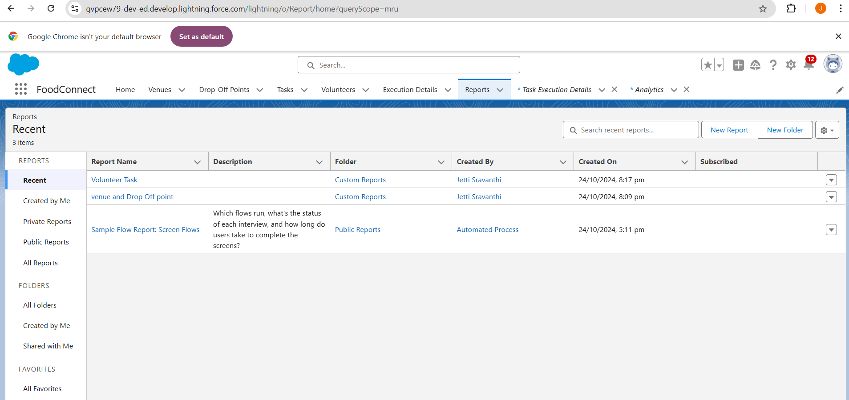

Adding venue and Drop Off point Report to the Dashboard:-

* Purpose: To visualize the "Venue and Drop Off Point" report data on a custom dashboard.
* Dashboard Name: Organization Details
* Folder: Custom Dashboards
* Report Selected: venue and Drop Off point Report
* Display As: Lightning Table
* Component Theme: Dark (Optional)

This allows real-time tracking of venue and drop-off point activities, making it easier to monitor and manage operations from the dashboard.

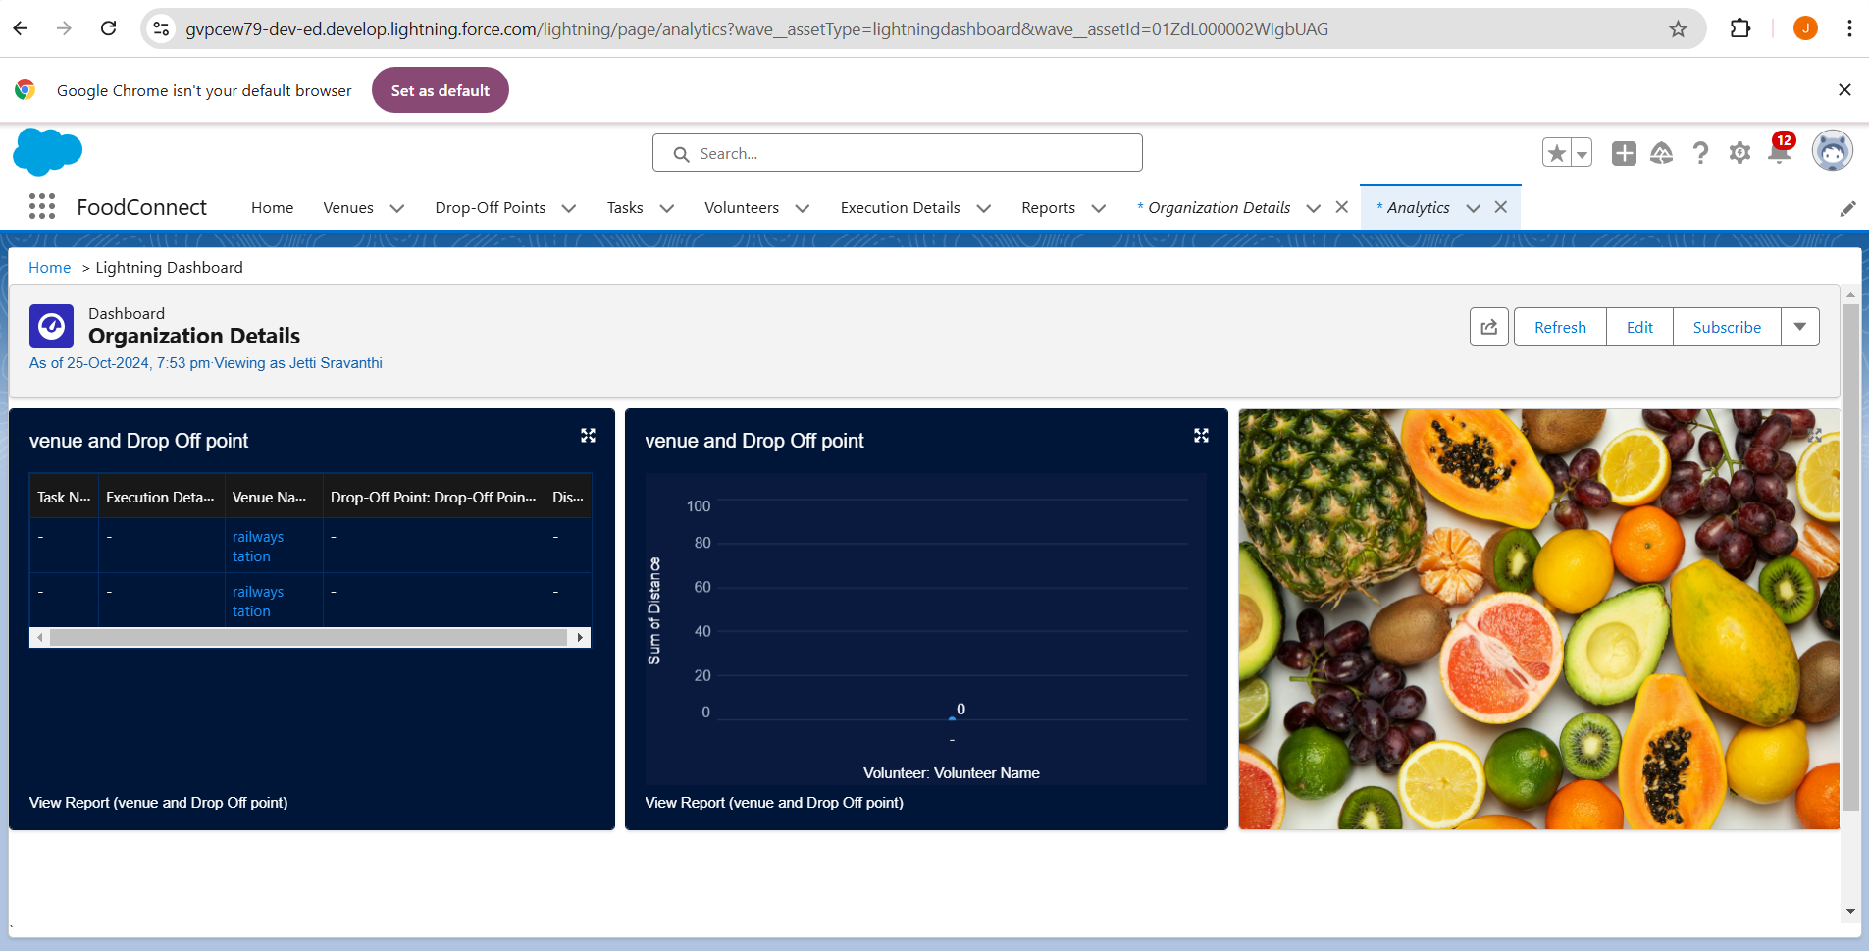

Adding "Volunteer Task" Report to the Dashboard

* Purpose: To visualize the "Volunteer Task" report on the dashboard for task tracking and performance analysis. Report Selected: Volunteer Task Report
* Display As: Line Chart
* Component Theme: Dark (Optional)

This setup provides a visual representation of volunteer tasks, aiding in monitoring task completion and volunteer performance efficiently on the dashboard.

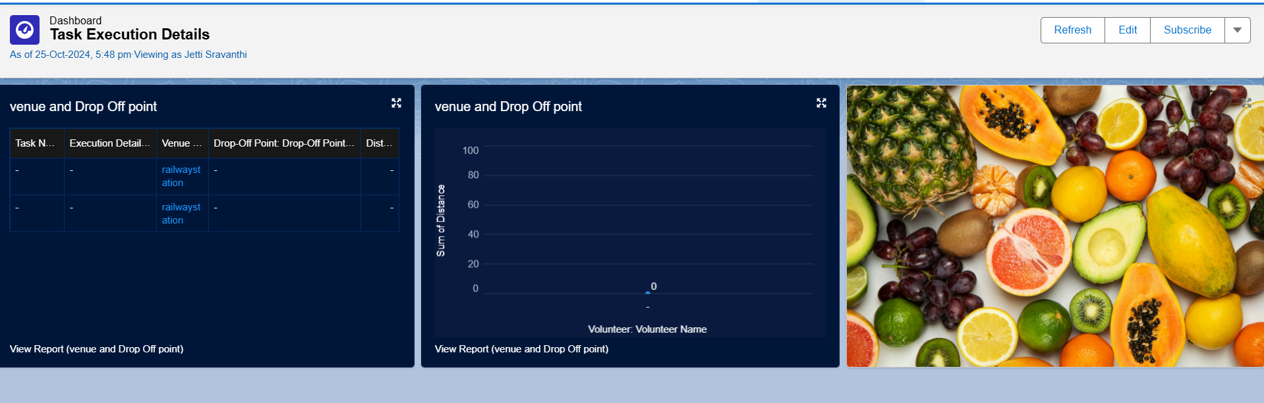

Creation of Sharing Rules

* Purpose: To control and manage access to Drop-Off point records based on distance criteria for different user groups.
* Rules:
  + Rule 1: Share Drop-Off points with a distance of less than 15 units with the "Iksha" Public Group.
  + Rule 2: Share Drop-Off points with a distance between 15 and 30 units with the "sjsj" Public Group.
  + Rule 3: Share Drop-Off points with a distance between 30 and 50 units with the "jsj" Public Group.

**Home Page:-**

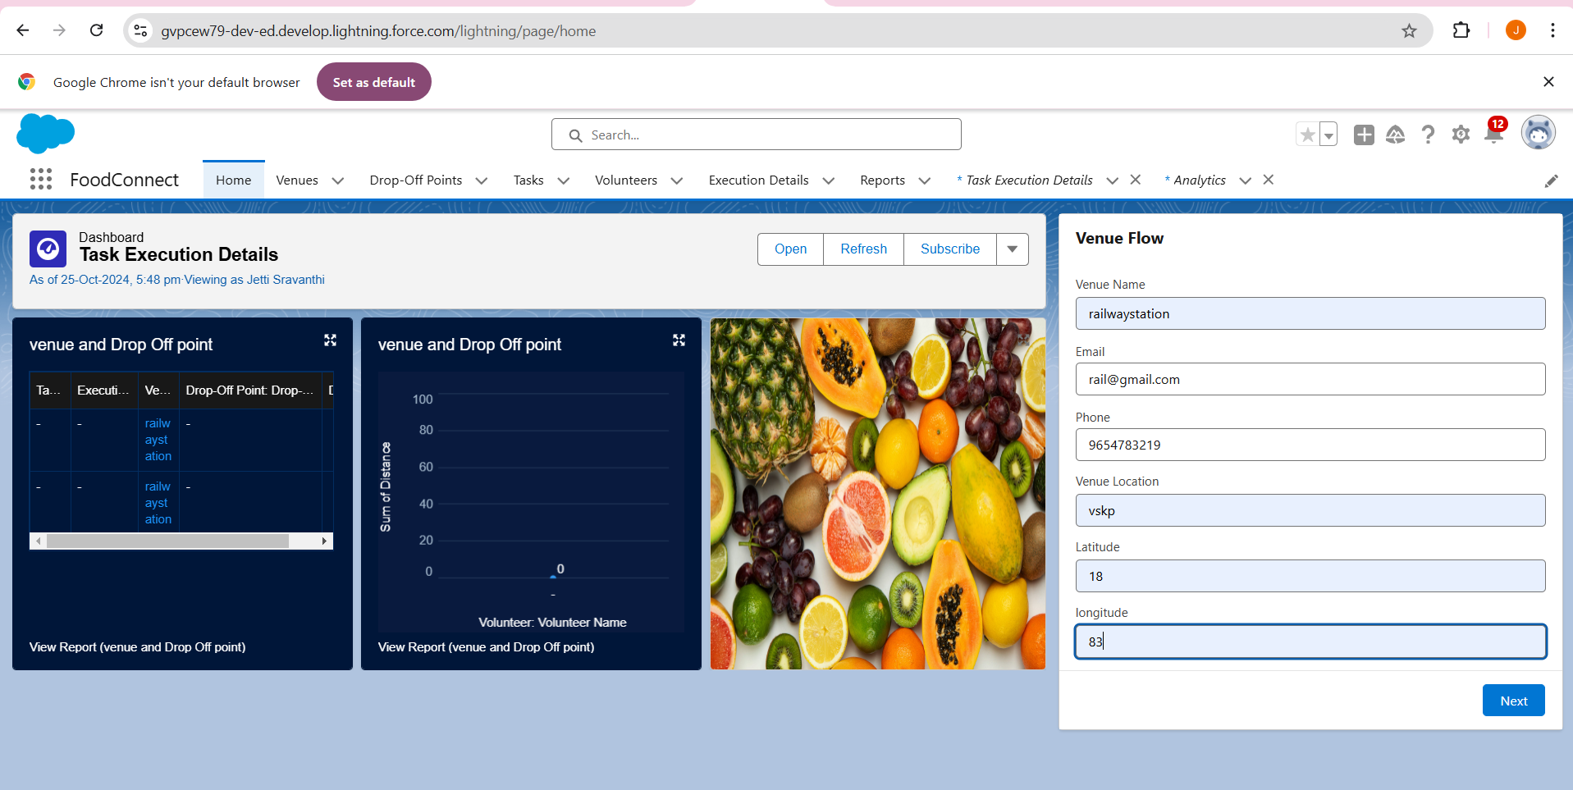

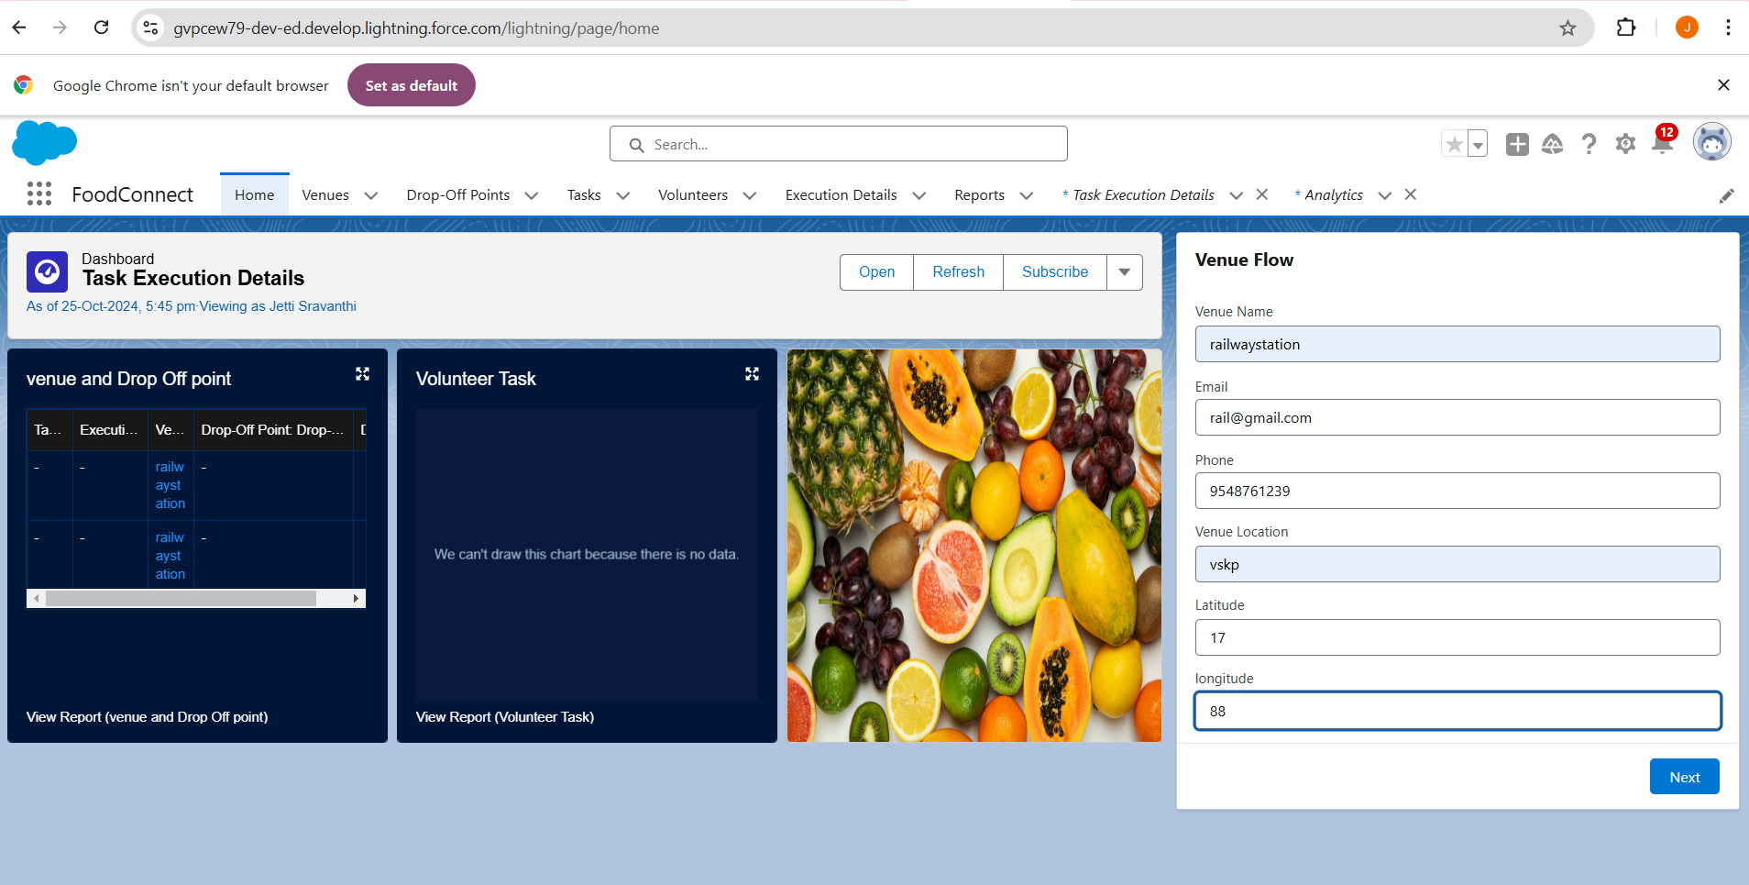

**Conclusion:**-

Designing a custom Home Page for the FoodConnect App brings together crucial elements like the Venue Flow and Dashboard, creating a unified and efficient interface for managing essential functions. This tailored layout allows users to seamlessly access reports, interactive flows, and key data, significantly boosting productivity and improving the overall user experience within the FoodConnect application

**Salesforce URL:**[gvpcew79-dev-ed.develop.my.salesforce.com](http://gvpcew79-dev-ed.develop.my.salesforce.com)